Project E-commerce

Below are the factors which are affecting business basically:

1) **Month of Sales**:

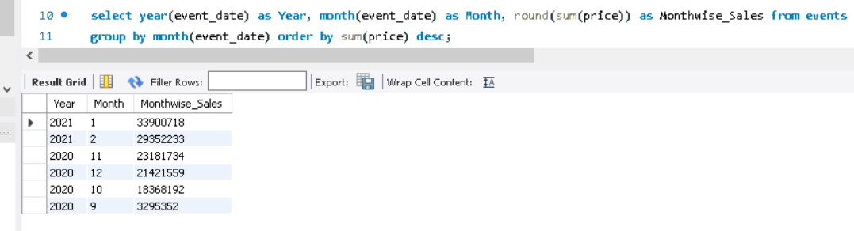

There is highest sale in **January** month which is 33900718 and lowest sale in **September** month which is 3295352.

2)**Top Time of Visit**:

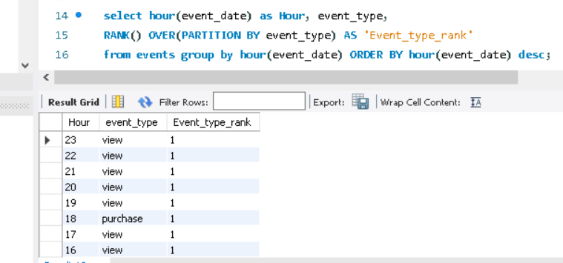

Time of view is more than time of purchase.

3)**Top brands by Sales:**

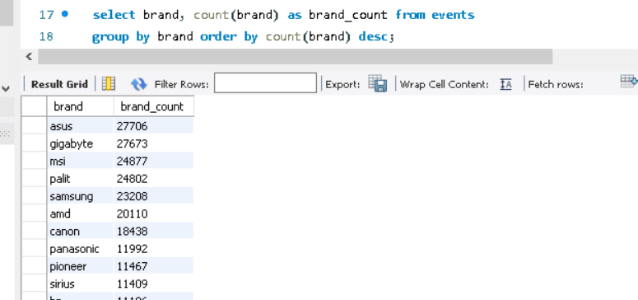

These brands are top brands in a given list. Top 6 brands are as follows:

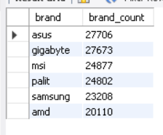

4)**Demand for Items**

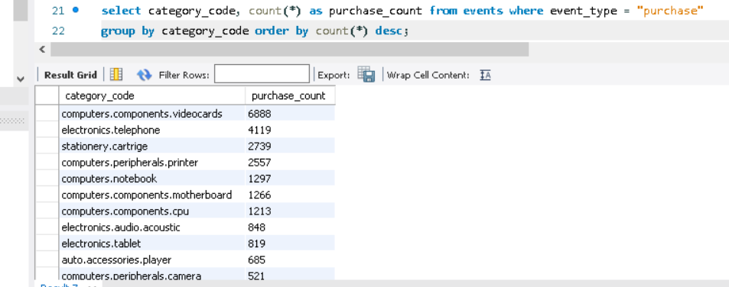

These are most demanded items having max purchase count is 6888.

5)**Frequency of Purchase**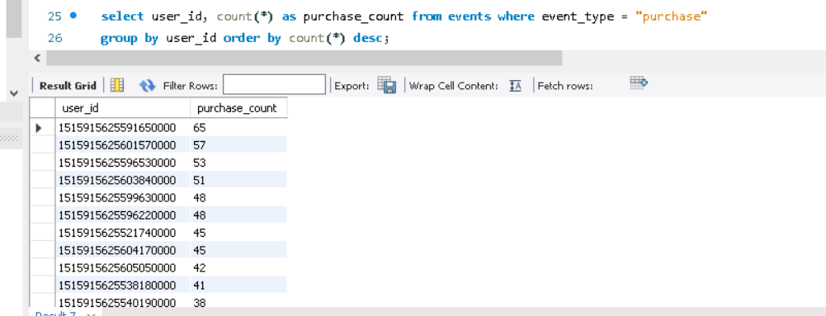

The user id 151591562559165000 is topmost from customers having max purchase count which is 65

6)**Actual Time purchased**

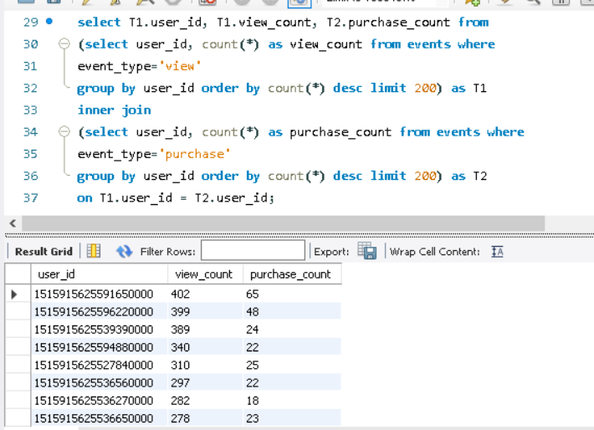

Total view count is more than purchase count from that we can conclude that people are viewing more items but not actually purchasing them.